CIS 430: Lab Assignment 3

Name: Yuvaraj Vagula

ID: 2862494

Object: Querying a Relational Database COMPANY Database

1. **Added myself inside EMPLOYEE, DEPENDENT, WORKS_ON table then used a single SELECT to get my entries.**

-- Insert myself into the EMPLOYEE table

INSERT INTO EMPLOYEE (FNAME, MINIT, LNAME, SSN, BDATE, ADDRESS, SEX, SALARY, SUPERSSN, DNO)

VALUES ('Yuvaraj', 'N', 'Vagula', '777777777', '2006-05-01', '2121 Euclid Ave, Cleveland, OH', 'M', 50000, '123456789', 5);

-- Insert a dependent, a Bird named Timmy, with the same ESSN value

INSERT INTO DEPENDENT (ESSN, DEPENDENT_NAME, SEX, BDATE, RELATIONSHIP)

VALUES ('777777777', 'Timmy', 'M', '2022-05-01', 'Bird');

-- Insert my data into WORKS_ON with the same ESSN value

INSERT INTO WORKS_ON VALUES ('777777777', 3, 20);

INSERT INTO WORKS_ON VALUES ('777777777', 4, 20);

-- One SELECT to get my entries I just entered

SELECT E.FNAME, E.MINIT, E.LNAME, E.SSN, E.BDATE, E.ADDRESS, E.SEX, E.SALARY, E.SUPERSSN, E.DNO,

D.DEPENDENT_NAME, D.SEX AS DEP_SEX, D.BDATE AS DEP_BDATE, D.RELATIONSHIP,

W.PNO, W.HOURS

FROM EMPLOYEE E

LEFT JOIN DEPENDENT D ON E.SSN = D.ESSN

LEFT JOIN WORKS_ON W ON E.SSN = W.ESSN

WHERE E.SSN = '777777777'; 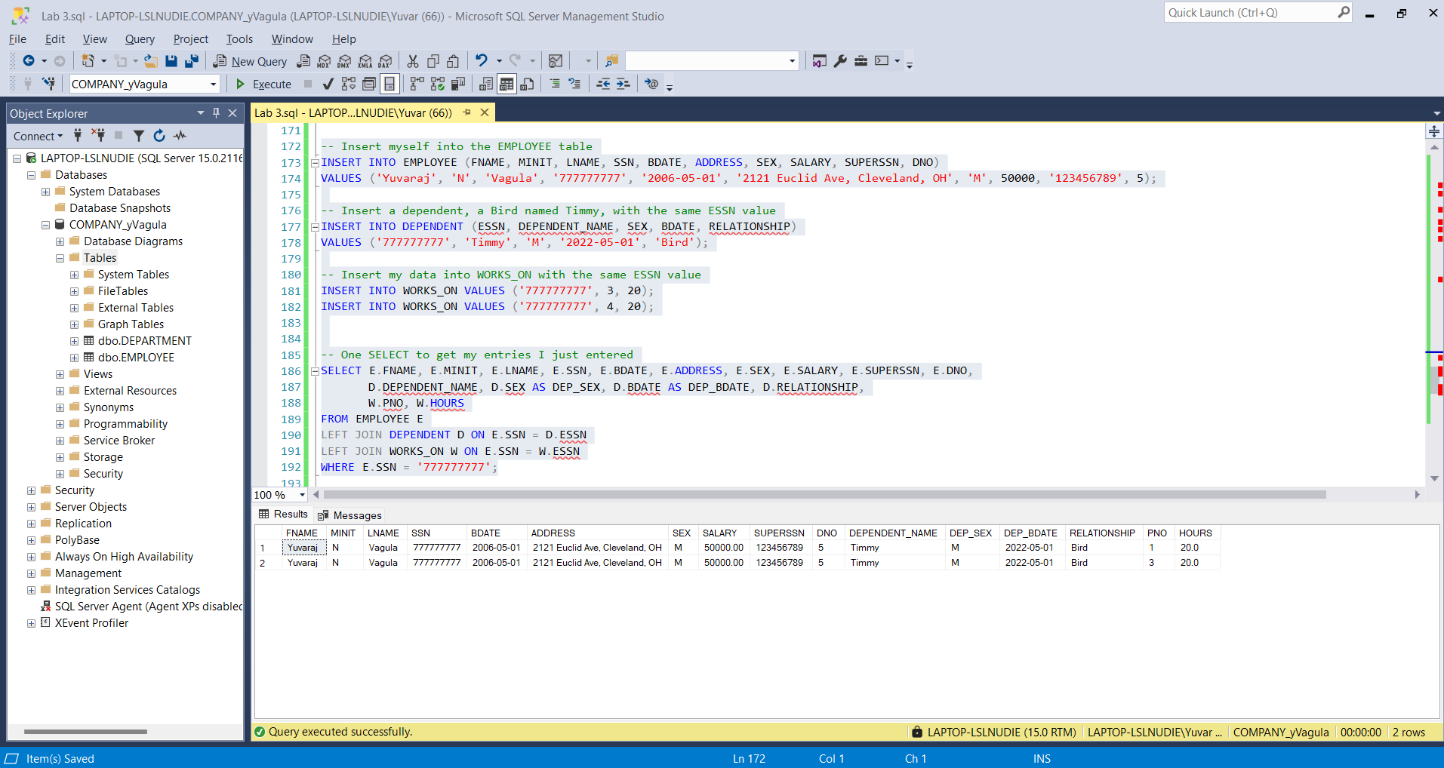

**Q1) Getting female managers names & addresses**

-- Q1: Retrieve the name and address of all the female managers

SELECT E.FNAME, E.LNAME, E.ADDRESS

FROM EMPLOYEE E

JOIN DEPARTMENT D ON E.SSN = D.MGRSSN

WHERE E.SEX = 'F';

**Q2) A list of all project numbers for projects that involve an employee whose last name is ‘Smith’, either as a worker or as a manager of the department that controls the project.**

-- Q2: List all project numbers for projects involving an employee whose last name is 'Smith'

SELECT DISTINCT P.PNUMBER

FROM PROJECT P

JOIN DEPARTMENT D ON P.DNUM = D.DNUMBER

JOIN EMPLOYEE E1 ON D.MGRSSN = E1.SSN

LEFT JOIN WORKS_ON W ON P.PNUMBER = W.PNO

LEFT JOIN EMPLOYEE E2 ON W.ESSN = E2.SSN

WHERE E1.LNAME = 'Smith' OR E2.LNAME = 'Smith';

**Q3) Retrieve the name and address and his/her department name of the highest ranked employee who does not report to anybody in the company.**

-- Q3: Retrieve the name and address and department name of the highest-ranked employee who does not report to anybody

SELECT TOP 1 E.FNAME, E.LNAME, E.ADDRESS, D.DNAME

FROM EMPLOYEE E

JOIN DEPARTMENT D ON E.DNO = D.DNUMBER

WHERE E.SUPERSSN IS NULL

ORDER BY E.SALARY DESC;

**Q4) For each department, list all the employees who are working in the department with the employee’s first and last name and first and last name of his or her immediate supervisor. List the result in the order of each department number and department name.**

-- Q4: For each department, list all employees with their immediate supervisor's names

SELECT D.DNAME, E1.FNAME AS EMP_FNAME, E1.LNAME AS EMP_LNAME, E2.FNAME AS SUP_FNAME, E2.LNAME AS SUP_LNAME

FROM DEPARTMENT D

JOIN EMPLOYEE E1 ON D.DNUMBER = E1.DNO

LEFT JOIN EMPLOYEE E2 ON E1.SUPERSSN = E2.SSN

ORDER BY D.DNUMBER, D.DNAME;

**EXTRA POINTS) Include all the employees who do not have any supervisor as well in the list.**

-- Extra points: Include employees without supervisors

SELECT D.DNAME, E1.FNAME AS EMP_FNAME, E1.LNAME AS EMP_LNAME, COALESCE(E2.FNAME, 'No Supervisor') AS SUP_FNAME, COALESCE(E2.LNAME, '') AS SUP_LNAME

FROM DEPARTMENT D

JOIN EMPLOYEE E1 ON D.DNUMBER = E1.DNO

LEFT JOIN EMPLOYEE E2 ON E1.SUPERSSN = E2.SSN

ORDER BY D.DNUMBER, D.DNAME;

**PROOF OF PATH AND FILENAME**

